**PJ 12 Report My Name: __Yaowei Lei__**

**A. The following is my Python source program:**

**// Please copy your source program into here from your Visual Studio IDE.**

**// Your code here must be in color. You must not show screen prints here.**

#-----------------------------------------------------------------------------------------------------------.

# Author: Yaowei Lei

# Date: 12/14/2021

# Purpose: CS119-PJ12: List Sorting & Searching Game – show numbers from user in ascending order and arrowed to search.

#-----------------------------------------------------------------------------------------------------------.

def swap(lyst, i, j): # to swap 2 elements (sub i and sub j ) in the lyst.

temp = lyst[i]

lyst[i] = lyst[j]

lyst[j] = temp

def selectionSort ( lyst ): # to sort the lyst. You must not use lyst.sort( ) in your program.

i = 0

while i < len(lyst) - 1: # Do n – 1 searches

minIndex = i # for the smallest item

j = i + 1

while j < len(lyst): # Start a search

if lyst[j] < lyst[minIndex]:

minIndex = j

j += 1

if minIndex != i: # Swap if necessary

swap(lyst, minIndex, i)

i += 1

def binarySearch(target, lyst): # to search target number in the lyst, which is an array in Python. You must not use lyst.index(target) in your program. binarySearch function will return the position that the target is in.

left = 0

right = len(lyst) - 1

while left <= right:

midpoint = (left + right) // 2

if target == lyst[midpoint]:

return midpoint

elif target < lyst[midpoint]:

right = midpoint - 1 # Search to left

else:

left = midpoint + 1 # Search to right

return -1

def sum( L ): # return the sum of all numbers in the L list

s = 0 # to prepare for the summation of all numbers in the L list

for i in range(len(L)): # i to range thru all members in L list

s += L[i] # add sub i of L to s as accumulation

return s # s is the sum of all integers in the L list

def avg( L ): # average is sum divided by number of items. len( L ) function will return the length of L list

return ( sum( L )/len( L ) )

# MAIN PROGRAM: ================================================.

print ("Welcome to the List Sorting/Searching Game of \"Yaowei lei\"!")

n = 1 # line number for each separation line for readability

print(n,"=============================================================");n=n+1;

while True :

List = [ ] # create an empty list.

numberOfInt = int(input ("Please enter how many integers you would like to play (up to 20, 0 to stop) > "))

while numberOfInt < 0 :

numberOfInt = int(input ("Please enter how many integers you would like to play (up to 20, 0 to stop) > "))

if numberOfInt == 0 :

break

for i in range(numberOfInt) : # get the number of integers from user

number = int(input ("Please enter number> "))

List.append(number) # add integer to the List

selectionSort(List) # to sort the lyst.

print ("Your",numberOfInt,"integers in ascending order are: ", end = "") # show the list

for i in range(len(List)) :

print( List[i], " ", end = "" ) # print the list of numbers on the same line

print(" ") # to end this line of showing all integers in list L

print ("Sum is",sum(List), "and average is %.0f" %avg(List))

print(n,"=============================================================");n=n+1;

while True :

search = int(input ("Please enter a number to search (-99 to end the search)> "))

if search == -99 :

break

if binarySearch(search, List) != -1 :

print ("The number", search, "is found at the position", binarySearch(search, List)+1)

else :

print ("The number", search, "is not found. ")

print(n,"=============================================================");n=n+1;

print (n,"============================================================"); n+=1;

print("Thank you for playing the List Sorting/Searching Game of \"Yaowei lei\"!")

print (n,"============================================================"); n+=1;

# End of MAIN PROGRAM ============================================.

# End of Program ########################################

**B. The following is the console output of my 3 test runs:**

**// One way to copy the console output is to press Ctrl+Alt+PrtScn.**

**// Another way to copy is to use the snipping tool. To paste the image is to press Ctrl+v.**

**// The console display must not be too wide, otherwise it will be too hard to read once pasted.**

**// Please make sure your console is long enough to show all your output lines to be captured.**

**// Please copy your console output and paste into here:**

**Test Case #1:**

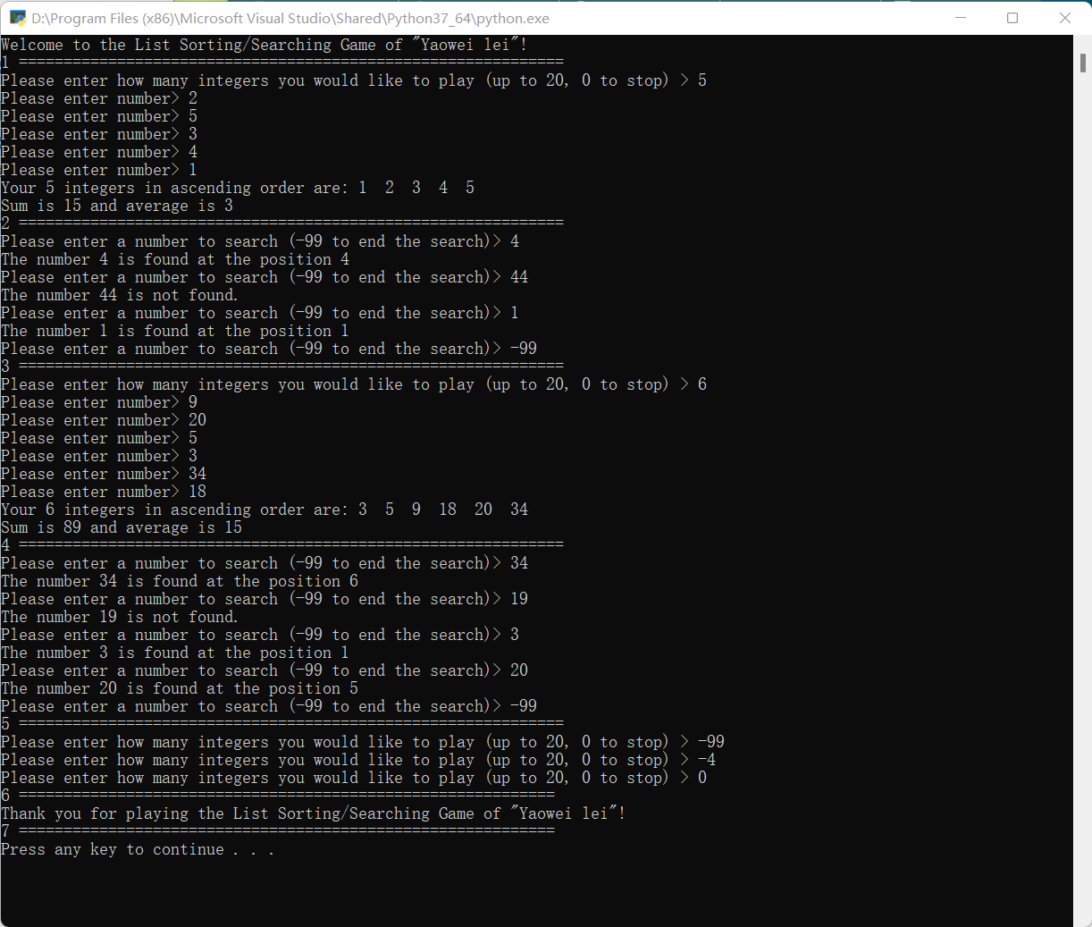

**Test Case #2:**

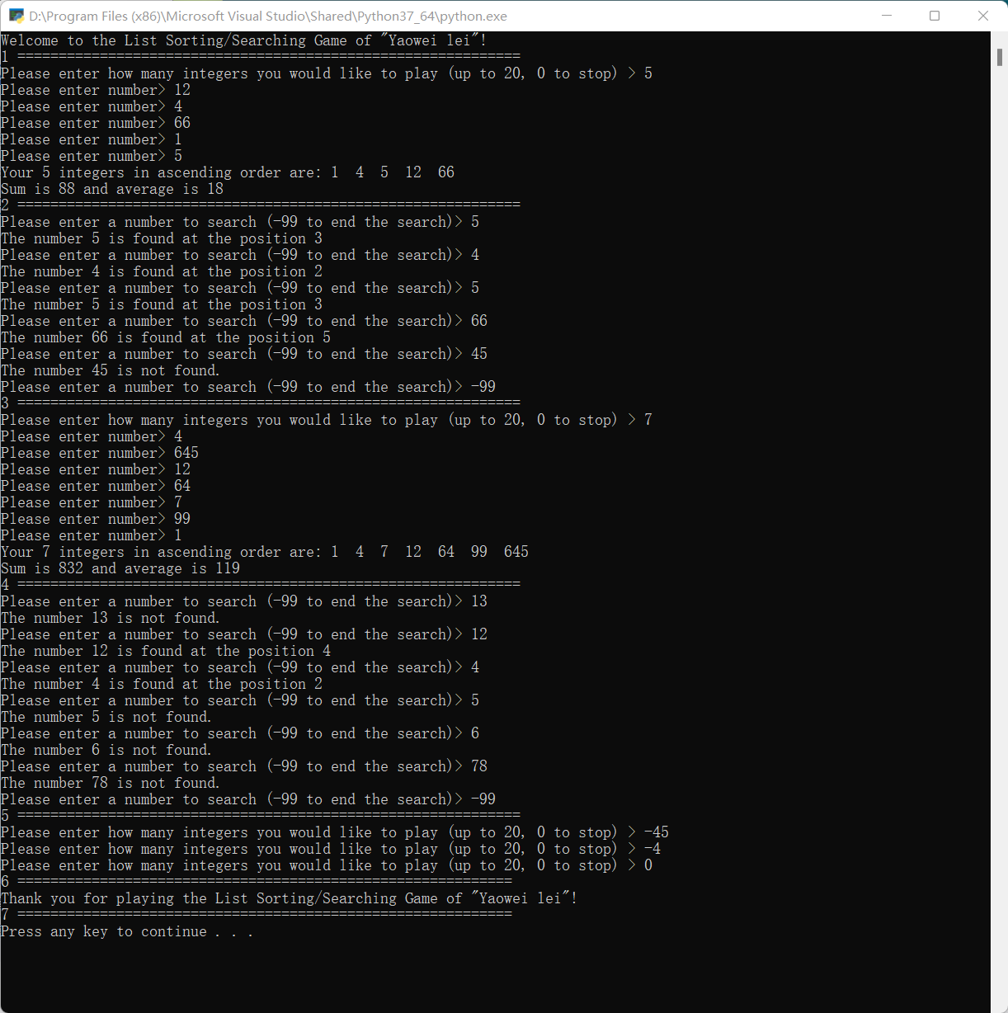

**Test Case #3:**

